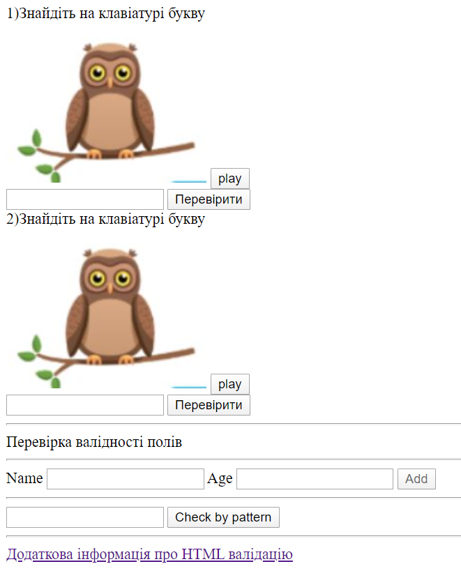
<!DOCTYPE html>
<html lang="en">
<head>
<meta charset="UTF-8" />
<meta name="viewport" content="width=device-width, initial-scale=1.0" />
<meta http-equiv="X-UA-Compatible" content="ie=edge" />
<title>Document</title>
<script src="https://cdn.jsdelivr.net/npm/vue/dist/vue.js"></script>
</head>
<body>
<div id="app">
<div v-for="(card,index) in cards">
<div class="header">
{{card.question}}
</div>
<div>
<img :src="card.imagePath" alt="image" />
<button @click="playAudio(index)">play</button>
</div>
<div>
<input :ref="`ans_${index}`" type="text" />
<button @click="checkAnswer(index)">Перевірити</button>
</div>
<audio :ref="`mp_${index}`" :src="card.audioPath"></audio>
</div>

<!-- <input ref="test" type="text" minlength="5" maxlength="7" /> -->

<hr />
Перевірка валідності полів
<hr />
<label>
Name
<input
ref="nameInp"
type="text"
v-model="name"
minlength="3"
maxlength="10"
/>
</label>
<label>
Age
<input type="number" v-model="age" />
</label>
<button @click="addItem" :disabled="!isDataValid">Add</button>
<hr />
<input ref="test" type="text" pattern="\d{3}\/\d{2}" />
<button @click="check">Check by pattern</button>
<hr />
<a
href="https://developer.mozilla.org/en-US/docs/Learn/Forms/Form_validation"
>Додаткова інформація про HTML валідацію</a
>
</div>
<script>
var app = new Vue({
el: "#app",
data: {
cards: [
{
id: 1,
question: "1)Знайдіть на клавіатурі букву ",
imagePath: "./images/owl.jpg",
audioPath: "./audio/example.mp3",
rightAnswer: "a"
},
{
id: 2,
question: "2)Знайдіть на клавіатурі букву ",
imagePath: "./images/owl.jpg",
audioPath: "./audio/example.mp3",
rightAnswer: "b"
}
],
name: null,
age: null
},
computed: {
isDataValid() {
return this.name && this.$refs.nameInp.validity.valid && this.age;
}
},
watch: {},
methods: {
check() {
if (this.$refs.test.validity.valid) alert("ok");
else alert("no");
},

playAudio(index) {
console.log(`mp_${index}`);
console.log("this.$refs");
console.log(this.$refs);

this.$refs[`mp_${index}`][0].play();
},
checkAnswer(index) {
const userAnswer = this.$refs[`ans_${index}`][0].value;
if (this.cards[index].rightAnswer === userAnswer.toLowerCase())
alert("Ok");
else alert("no");
},
addItem() {}
}
});
</script>
</body>
</html>

